1. write a SQL query to find Employees who have the biggest salary in their Department

select d.dep_name, e.emp_name, e.salary

from Employees e

inner join Department d

on e.dep_id = d.dep_id

where salary in

(select max(salary) from Employees group by dep_id)

order by d.dep_id;

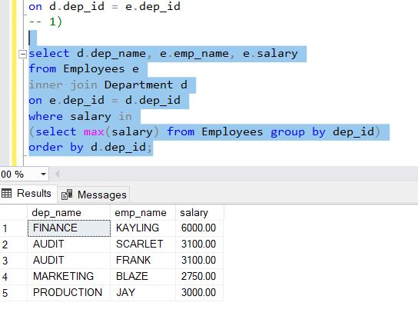

1. write a SQL query to find Departments that have less than 3 people in it

select d.dep_name, count(d.dep_name) as "department name"

from Employees e

inner join Department d

on e.dep_id = d.dep_id

group by d.dep_name

having count(d.dep_name) < 3

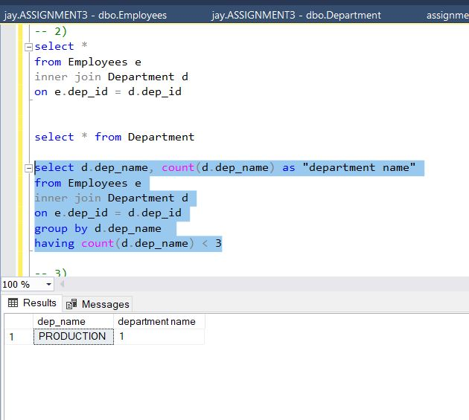

1. write a SQL query to find All Department along with the number of people there

select d.dep_name, count(d.dep_name) as "number of people"

from Employees e

inner join Department d

on e.dep_id = d.dep_id

group by d.dep_name

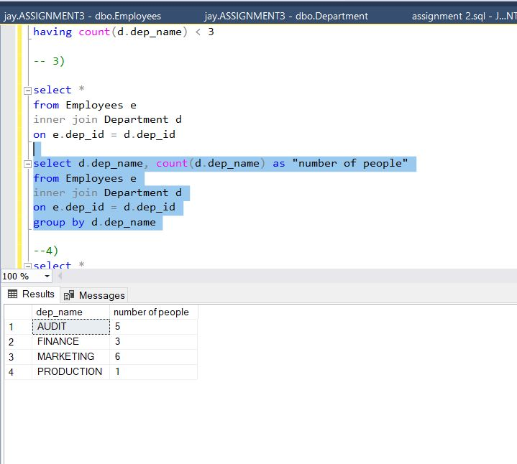

1. write a SQL query to find All Department along with the total salary there

select d.dep_name as "department name", SUM(e.salary) as "total salary"

from Employees e

inner join Department d

on e.dep_id = d.dep_id

group by d.dep_name

